**Privacy policy for WallsHub**

Welcome to the privacy policy. Here you’ll find how we use data we collect from WallsHub in order to make it work.

**Terms**

In order to let you understand correctly our privacy policy, you need to know these terms:

* **We:** when the word “we” is shown, it is referred as “Universal Apps Oficial”.
* **AdMob:** a service provided by Google that allows developers to add advertisement to their apps on Android or iOS. Official link: <https://www.google.es/admob/>
* **OneSignal**: a service that provides developers the ability to send notifications to their websites or apps easily and allow developers to see how the notifications perform (statistics about how the notifications are received, such as received, clicked, failed)
* **The app** or **Our app:** this refers to the app WallsHub.
* **Data** or **information**: this means anything that we collect.

**What data we collect**

We collect **only data that don't identifies you.** Specifically, we collect the following data through these ways:

* **OneSignal:** statistics about how the notifications are received (such as received, clicked, failed)
* **AdMob:** statistics on how the ads perform (such as how many times an ad has been seen generally or Android advertisement identifier)

The **only** data we can see is the one that Google (AdMob) and OneSignal shows us. Any other data that's collected but not showed to us, is subject to the privacy policy of the service provider respectively:

* **AdMob:** <https://policies.google.com/privacy?hl=en&gl=es> (Google’s privacy policy)
* **OneSignal:** <https://onesignal.com/privacy_policy> (OneSignal's privacy policy)

**Wait, do you sell my information even if it can’t identify me?!?!**

No. We **don't** sell any data, even if it can't identify you.

**Then, how you use my information?**

We only use your data to see how the advertisement on our app is performing and how the notifications we send are performing

**How can I opt-out of the data collection?**

You can opt-out from data collection through OneSignal’s service directly from the app following these instructions:

1. Open WallsHub
2. Open Settings
3. Go to the bottom
4. Disable the option “Enable notifications”

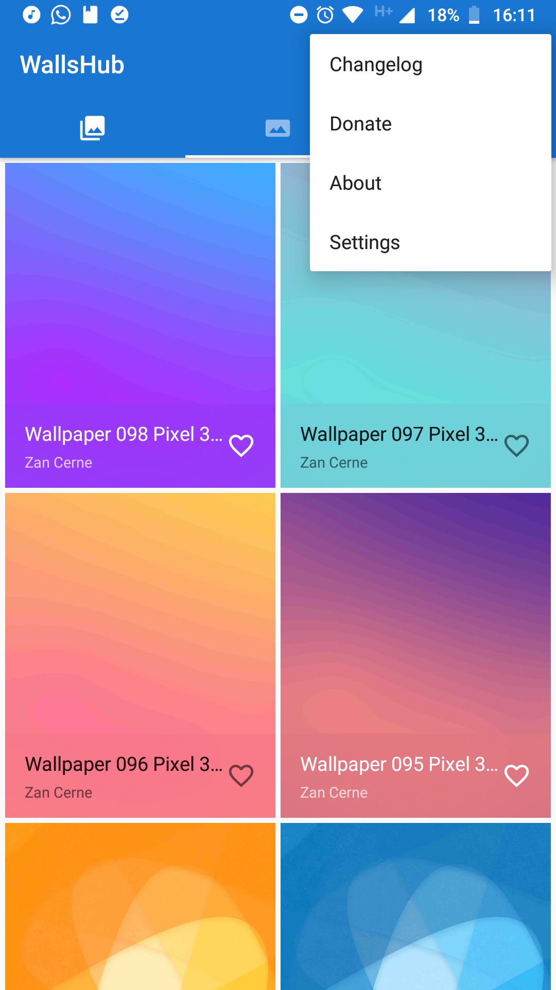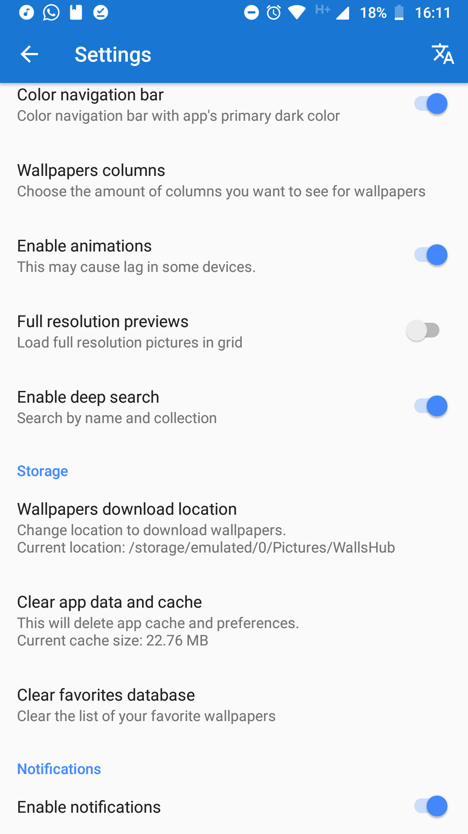

After this procedure, the only data we can see is that a user unsubscribed from the app's notifications, but not the specifical user.

However, you can't opt-out of the data collection on Google AdMob's service.

**Why do you use x or y permission on my device?**

Here's a description on how we use the permissions on your device:

* **Storage:** to save the wallpaper temporarily to apply it.
* **Internet connection**: to get the wallpapers and send the data we mention here.

**I have another question/more information on how you use my data.**

Send us an email to [helpUniversalApps@gmail.com](mailto:helpUniversalApps@gmail.com) and we're going to be happy to help you :)